

VOL 17 ISSUE 1

Winter 2013

ART 10 & 20 COURSE OUTLINE

What is it? How long?

Art 10 no art experience is necessary. Trying and being willing to play will ensure success (as well as handing in your assignments!). Art 10 is a general course aimed at exposing you to a wide variety of art media. Art 20 is developing what you learned in Art 10.

There are approximately 18 weeks of instruction. Classes are 60 minutes long from Monday to Friday.

Arriving on time, your attendance, attitude and effort are important factors in this class (and in life). What you put in, is what you’ll get out of the course.

Areas of Study.

You will study, learn and create a variety of projects. Through these assignments, you will develop your understanding of the elements and principles of design, your skills in handling various media and a chance to express yourself creatively. There will also be opportunities to work with others.

Depending on time, the possibilities are:

**The Elements and Principles of Design**

Line, shape, colour...

**Drawing**

Pencil, pencil crayon, charcoal, ink, pastels…

**Painting**

Tempera, ink, watercolours, acrylics...

**Printmaking**

Mono, stamp, lino, silkscreen…

**3 Dimensional**

Papier mache, wire, hemp, clay...

**Evaluation of work**

Yours and others…

**Art History**

Throughout the course…

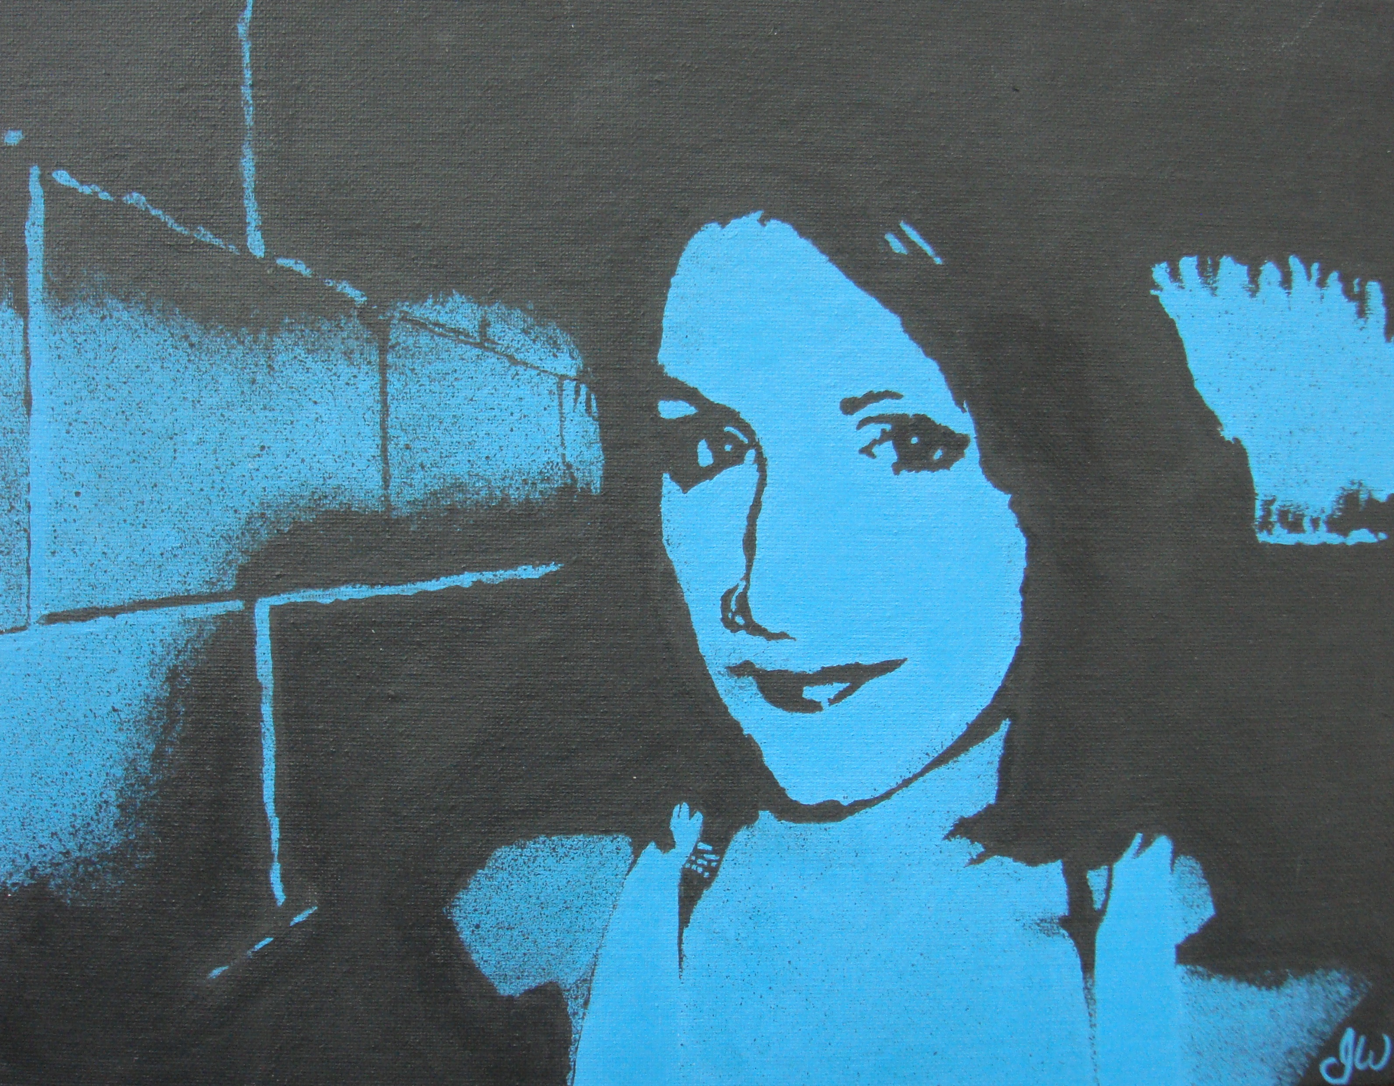



**Glue Stick**

**Rubber Cement** (120ml, in glass container)

**Old t-shirt** for covering your clothes

***OPTIONAL Supplies, strongly encouraged:***

**Ruler** (12 inches or 30 cm)

**Scissors** (good quality)

**White Glue** (150 ml or larger)

Supply List

Supplies are due in class: ____________

If you have any problems in obtaining any of the supplies, please let me know as soon as possible.

The supplies needed for class can be used in your home, after you have completed this course, and can be saved and used the next time you take Art.

Once you purchase these supplies, you will bring them to class and they will remain in the Art Room for the remainder of the semester. Each student will have a drawer, in the Art Room, and will store their supplies there.

If you wish to bring other supplies that you might want to use in Art, please do.

**HB or 2B pencils** (5 are required)

**Pencil Crayons** (12, but 24 or more are better)

**White Eraser**

Art is an enjoyable class, but you can fail Art. You may not be the best artist, but if you put in a consistent effort everyday, you will do fine.

As mentioned before, arriving on time, your attendance, effort and attitude will make a BIG difference in what you get out of the course.

The key word is **RESPECT**. Respect the space, the materials and others. This semester, there are more than 150 art students using this room. Leave the space and the materials in a manner that you would like to use them, and treat others the way you want to be treated.

7 Basic Rules.

1. **Arrive on time.**
2. **Follow directions.**
3. **Keep your hands, feet and objects to yourself.**
4. **No swearing, teasing, name-calling or putdowns.**
5. **Don’t interrupt when someone else is speaking.**
6. **Bring all required materials to class.**
7. **Do not leave the room without permission.**

Cell phones may be used to listen to music (with headphones) or look up images. The following privilege (and the user’s phone) may be taken away. If texting/Facebooking/Twittering occurs, your phone will be taken away.

Art Club /Lunch time & More.

At lunchtime, the Art Room will be open to students (except for Ms. Burns lunch time supervision elsewhere and unless announced otherwise). This is a great opportunity to try something new, or do more of a certain medium. It is also a great time to get any extra help from Ms. Burns. You can also find it a great place to eat your lunch!!

**ALSO! Check out the EPC Art Webpage for updates and handouts on assignments, blog of interesting finds and more.** [**www.epcart.weebly.com**](http://www.epcart.weebly.com) **Password is: epc**

How you are marked.

You can be a budding Picasso, or have ‘no talent’ in Art, and you will still be able to learn and have fun in this class… and PASS! Art is a fun class, but you can fail Art. The students who fail Art do two things, they:

1. don’t hand in their assignments and/or
2. don’t work in class.

Therefore, how well you will do in this class is up to you. When you begin a new assignment, you will be given a mark sheet, or told, exactly how you will be marked.

Failure to hand in assignments result in a 0%. You will have between 1-2 weeks to hand in an assignment after it is due. Considering that this is worth 5 credits, just like Math, Chem and English, it is worth your effort to make sure you pass Art.

Every assignment, however large or small, will be marked.

You will be evaluated on your:

* Planning
* Project
* Evaluation *(of your work)*

*(see specific mark sheet)*

AND…..

Ms. Burns’ “Art work and Words,” photographs and blog can be found on her website : http://www.barbaraburns.ca

winter 2013

 Join **EPC Art Corner**



EXPECTATIONS

VOL 17 ISSUE 1