

**www.BarbaraBurns.ca**

Using an Art Magazine, cut out one image (or part of one) that shows 3 types of line. Clearly label what each type of line is and paste it below.

|  |  |  |
| --- | --- | --- |
| Straight | Horizontal | Vertical |
| Diagonal | Curving | Spiraling |
| Angular | Jagged | Thick |
| Thin | Parallel | Zigzag |
| Wide | Long | Short |
| Broken | Fuzzy | Blurred |
| Branching | Hatched | Sketchy |
| Gesture | Contour | Outline |
| Continuous | Gradated | Implied |
| Actual | Calligraphic | Perspective |
| Converging | Decorative |  |

LOOK at all the **DIFFERENT TYPES of LINES**

**LINE**

In the Visual Arts Glossary, define **line**.

______________________________________________________________________________________________________________________________________

**Elements of Design**

Name: ___________________________________________________ Block: ______________

**www.BarbaraBurns.ca**

Organic shape goes here…..

Geometric shape goes here…..

Using an Art Magazine, find an example of each type of shape (geometric & organic), cut it out, and paste it in the correct box below. Identify (i.e. clearly label!) what shape you are showing me for this example.

In the Visual Arts Glossary, define **organic shape**.

______________________________________________________________________________________________________________________________________________________

In the Visual Arts Glossary, define **geometric shape**.

______________________________________________________________________________________________________________________________________________________

------------------------------------------------------------------

**SHAPE**

In the Visual Arts Glossary, define **shape**.

______________________________________________________________________________________________________________________________________

**www.BarbaraBurns.ca**

Shade these implied shapes to show form.

LIGHT

From an Art magazine, find an implied form from a drawing or painting. Cut it out and glue it into this section.

**HINT**

**FORM**

In the Visual Arts Glossary, define **form**.

______________________________________________________________________________________________________________________________________

In paintings and drawings, form is implied as it isn’t really three dimensional on your page (it is still flat to the touch!). Artists create the look of form, in drawings and paintings through the use of shading (values).

**www.BarbaraBurns.ca**

On the following page, take the tempera paints out and paint the tints & shades, of each color, using black and white.

On the following page, take the tempera paints out and paint the primary, secondary & tertiary colors using ONLY the primary colors!!

**COLOUR**

In the Visual Arts Glossary, define **color** (colour!).

______________________________________________________________________________________________________________________________________

In the Visual Arts Glossary, define **hue.**

______________________________________________________________________________________________________________________________________

In the Visual Arts Glossary, define **primary colors**.

______________________________________________________________________________________________________________________________________ In the Visual Arts Glossary, define **secondary colors**.

______________________________________________________________________________________________________________________________________ In the Visual Arts Glossary, define **tertiary colors**.

______________________________________________________________________________________________________________________________________

In the Visual Arts Glossary, define **monochromatic**.

______________________________________________________________________________________________________________________________________ In the Visual Arts Glossary, define **tint**.

______________________________________________________________________________________________________________________________________ In the Visual Arts Glossary, define **shade**.

______________________________________________________________________________________________________________________________________

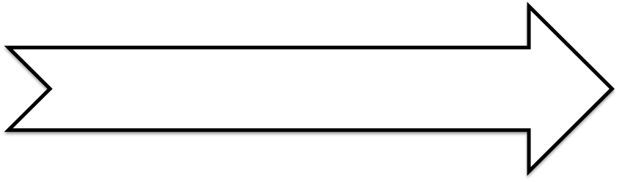

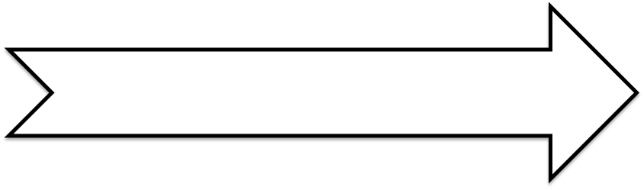

**www.BarbaraBurns.ca**

Paint the color (hue) in each middle section. On the outer edges, you will paint each color’s shades. In the inner sections, you will paint each color’s tints.

T

i

n

t

Shade

Purple

R-P

Red

O-R

Orange

Y-O

P-B

Blue

G-B

Green

Y-G

Yellow

**www.BarbaraBurns.ca**

Creating various ‘browns’ using… (remember to use EQUAL amounts of each color)… and paint the following….

|  |  |  |
| --- | --- | --- |
| RED | GREEN | Red + Green in equal amounts create ‘brown’ |

|  |  |  |
| --- | --- | --- |
| BLUE | ORANGE | Blue + Orange in equal amounts create ‘brown’ |

|  |  |  |
| --- | --- | --- |
| YELLOW | PURPLE | Yellow + Purple in equal amounts create ‘brown’ |

Oh NO!!!

You don’t have an already made brown paint!

No worries as you can always create brown (brown/greyish brown) by combining EQUAL amount of complementary colors together!

Red + Green… (think Christmas)

Blue + Orange…. (think Edmonton Oilers)

Yellow + Purple… (think Easter)

Hint: How to make browns….

In the Visual Arts Glossary, define **complementary**.

______________________________________________________________________________________________________________________________________

**www.BarbaraBurns.ca**

Creating various colors by mixing in (a little bit) that color’s complementary color… and paint the following….

|  |  |  |
| --- | --- | --- |
| RED | RED + a small amount of GREEN  *It still looks red* | Red + abit more of Green added  *It still looks red* |

|  |  |  |
| --- | --- | --- |
| BLUE | BLUE + a small amount of ORANGE  *It still looks blue* | Blue + abit more of Orange added  *It still looks blue* |

|  |  |  |
| --- | --- | --- |
| YELLOW | YELLOW + a small amount of PURPLE  *It still looks yellow* | Yellow + abit more of Purple added  *It still looks yellow* |

You can change a colour’s intensity by doing 4 things….

* Add white to it
* Add black to it
* Add grey to it….AND….
* Add its complement to it

By adding the color’s complement color to it, you can create a wonderful range of that main color! (…deeper and richer reds…golden yellows….)

Choose a colour and put it in the first box. Then using your palette, add abit of that colour’s complement colour to your first colour. Notice that it is still that colour, but not as bright. Paint that colour in the second box. Then, on you palette, add abit more of that colour’s complement colour to the already altered colour. Place this colour in the third box.

Making MORE colors!!!

In the Visual Arts Glossary, define **intensity**.

______________________________________________________________________________________________________________________________________

**www.BarbaraBurns.ca**

Create a smooth gradation, of values,

using pencil crayon & burnishing white pencil crayon on top:

Create a smooth gradation, of values,

using pencil & a smudger:

Create a smooth gradation, of values,

using tempera paint:

**VALUE**

In the Visual Arts Glossary, define **value**.

______________________________________________________________________________________________________________________________________

In the Visual Arts Glossary, define **value scale**.

______________________________________________________________________________________________________________________________________

**Create a 5 value scale: Using a pencil**

Beginning with the box on the right, leave it blank, as it will be the lightest value of the value scale. The box on the far left will be the darkest value, so shade it in completely black. With the three remaining, shade in to show a GRADUAL change from the lightest to the darkest.

|  |  |  |  |  |
| --- | --- | --- | --- | --- |
|  |  |  |  |  |

**www.BarbaraBurns.ca**

When you draw, it helps to focus on the space/shape that surrounds the object just as much as you focus on the object. In the box below, ***draw the negative space around the apple and you will find the apple will appear***. Then ***shade/colour the negative space***.

This helps you draw better!!!

**SPACE**

In the Visual Arts Glossary, define **space**.

______________________________________________________________________________________________________________________________________

|  |  |  |
| --- | --- | --- |
| *There can* ***be spaces between shapes****…*  *draw an example…* | *There can be* ***space between shapes to show a pattern****….*  *draw this…* | ***Space can show emptiness*** *and voids…. draw a shape in a corner & leave the rest of the space blank…* |
|  |  |  |

In the Visual Arts Glossary, define **positive space**.

______________________________________________________________________________________________________________________________________

In the Visual Arts Glossary, define **negative space**.

______________________________________________________________________________________________________________________________________

**www.BarbaraBurns.ca**

You can **create an illusion of depth (3D space) by using perspective**. On the shapes below:

1. Draw orthogonal lines to the centre dot.
2. Pencil in the necessary parallel lines (according to the shape).
3. Erase all unnecessary lines so that the shape/form remains.

**www.BarbaraBurns.ca**

Find **three textures surfaces**, make rubbings of them.

Rubbings can add the illusion of texture.

|  |  |  |
| --- | --- | --- |
|  | *Unscramble the letters below to create a word that matches its meaning.* | *Glue a sample below* |
| Texture that a person can *actual*ly touch. It is REAL. | “latuca”  *…is really….*  _____________________ |  |
| Texture that is drawn or painted. It is an illusion / NOT REAL.  *(Hint: this word was used on the first page for LINE and then on the FORM page)* | “diplime”  *…is really…*  *_____________________* |  |

**TEXTURE**

In the Visual Arts Glossary, define **texture**.

______________________________________________________________________________________________________________________________________