Emphasis
Emphasis is the stressing of a particular area of focus. When a composition has no emphasis nothing stands out. However the effective use of emphasis calls attention to important areas of the art work; it causes the eye to return to again and again.
One way of achieving emphasis is by creating center of interest, a.k.a. a focal point. A focal point is an area where the eye tends to ‘land.’ It is the focus of the viewer's attention. A focal point is created by making one area of element of the painting dominant, or most important visually with all other areas contributing but subordinate.
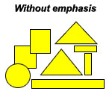
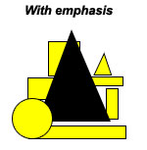

You can create emphasis by having your focal point:
- In the center of the artwork
- Large in size
- Bright/intense colour (compared to everything else… i.e. neon green vs subdued greens)
- Contrasting (i.e. different to everything else by detail, shape, texture, complementary colours..)
- Coloured in yellow or warm colours (while cooler or subdued colours in the background)
Pick 3 of the above, and show visual examples of this below:
In this example to show emphasis, I used

In this example to show emphasis, I used

In this example to show emphasis, I used

